**WEB SCARPING PROJECT**

**TITLE:- SPORTS**

**SPORTNAME AND TEAM :-BRAZIL FOOTBALL TEAM 2022**

**I AM GOING TO SCRAP THE PLAYERS NAME OF MEN NATIONAL TEAM WITH PLAYERS NAME ,TITLE AND IMG SOURCE**

**FIRST WE NEED TO IMPORT Beautifulsoup4,bs4 in order to proceed further.**

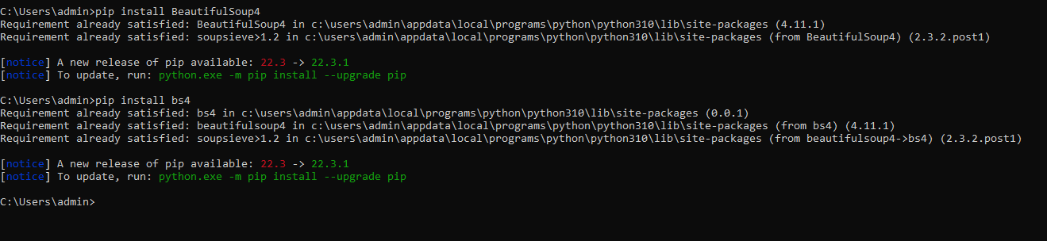

**import requests**

**from bs4 import BeautifulSoup**

**r=requests.get("https://www.espn.com/soccer/team/squad/_/id/205/brazil")**

**#print(r)**

**s=BeautifulSoup(r.content,'html.parser')**

**p=s.find('title').string**

**print(p)**

**print(s.title.parent.name)**

**for link in s.find_all('a'):**

**print(link.get('href'))**

**images = s.select('img')**

**for image in images:**

**src = image.get('src')**

**alt = image.get('alt')**

**images.append({"src": src, "alt": alt})**

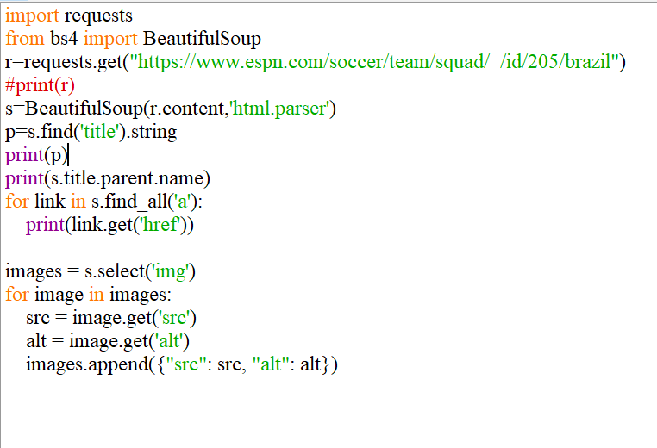

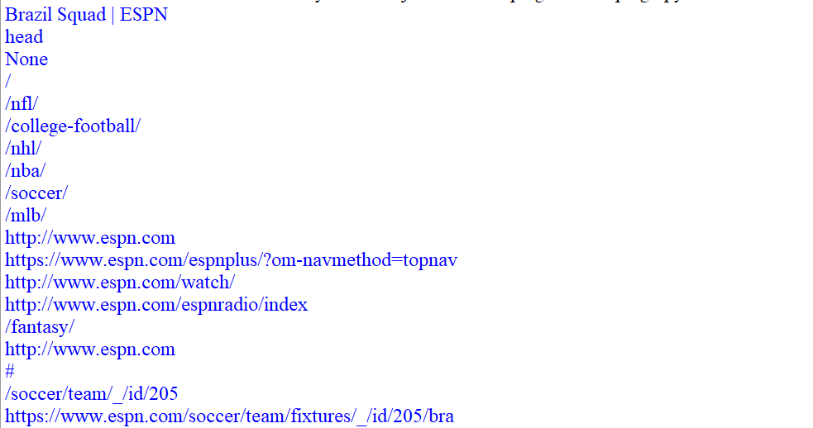

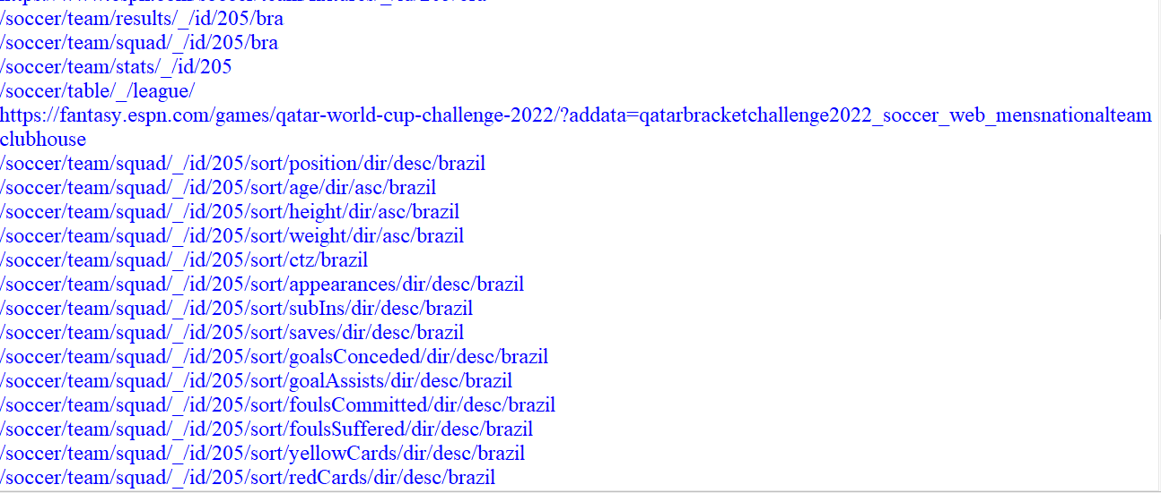

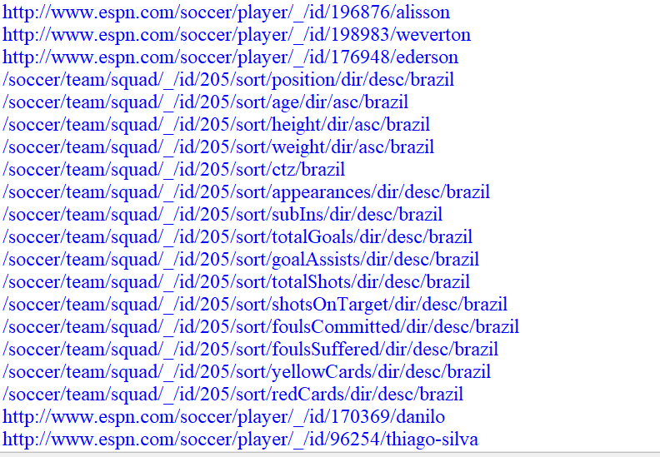

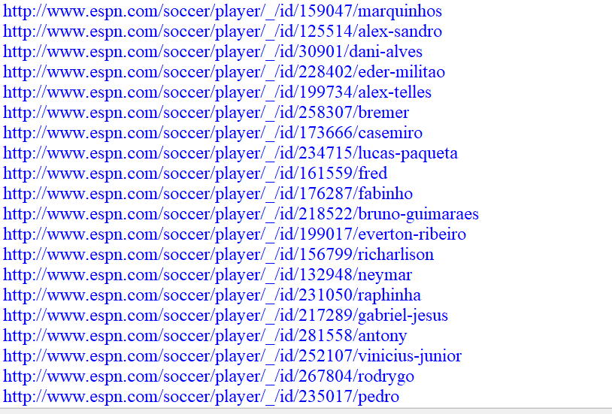

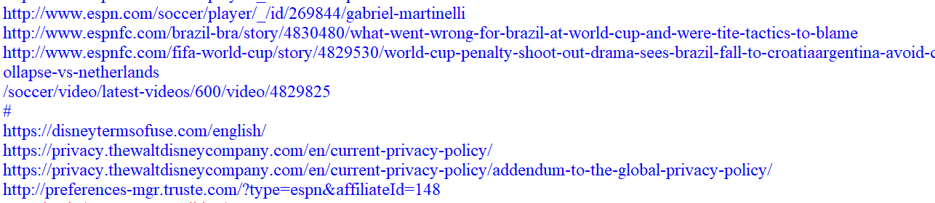

**RESULTS:- THE DATA HAS BEEN SCRAPED FROM THE WEBSITE SUCCESSFULLY**